The MB&F M.A.D.Gallery presents “American Trucks” by Ulysse Fréchelin – a stunning book and photographic exhibition

The MB&F M.A.D.Gallery has published its first ever book, “American Trucks”, a collection of stunning images by Swiss photographer Ulysse Fréchelin. The 100-page book is a joyous celebration of that archetypal icon gracing the American freeways: the trucking rig.

Evocative of America’s open-road culture and the freedom it entails, trucks have long transcended being mere modes of transport, becoming veritable symbols of identity for a nation and its people.

In “American Trucks”, Fréchelin’s clever use of close-ups and camera angles means it is not always evident at first glance what the subjects of the images are: Lustrous exhaust stacks, imperious radiator grilles, curvaceous fenders and riveted hoods of the tractor units; smooth or rippled panels of their trailers; shiny hub caps and chunky bolts of the wheels… Fréchelin turns these truck details on their head and showcases them in a totally fresh light, lending them a new identity. The stunning result is a series of portraits not of trucks per se but of whatever the beholder imagines them to represent.

Shooting in intense heat over a fortnight at truck stops on the Arizona-New Mexico border, Fréchelin emphatically succeeds in capturing the imposing proportions, gleaming chrome and vibrant colours of these automotive behemoths – bold yellows, greens and reds – as well as the dazzling light and vast blue skies of their backdrop – the mythical American West.

To accompany the launch of the “American Trucks” book – including a limited edition of 100 copies, each numbered and signed and in a slipcase – the M.A.D.Gallery is also hosting an exhibition of photos selected from the book.

Each image is available in a limited edition of 8 luxurious, large-format prints.

American Trucks: The Shooting
It was really by chance that Swiss photographer Ulysse Fréchelin came to shoot the glorious images for the book and exhibition “American Trucks” in the summer of 2013. He explains: “I had just arrived in Los Angeles to carry out work for a big American brand, but the shooting was cancelled at the last minute. With a couple of weeks to spare and on a whim, I set off for Santa Fe in New Mexico.

“I remembered the American artist Georgia O'Keeffe talking about the landscapes of New Mexico with such fervour that I wanted to see them, as well as visit her former house in Abiquiu. But I never did get to the house…”

Distracting Fréchelin from his artistic pilgrimage were the many trucks he saw dominating the freeways on the way to Santa Fe – Peterbilts, Kenworths and Macks, to name just a few. He was so fascinated by the trucks that he decided to start photographing them at truck stops – taking in Holbrook in Arizona, through to Gallup and Albuquerque in New Mexico.

These truck-stop settings are depicted appositely by Swiss poet Blaise Hofmann in his foreword to the “American Trucks” book: “Beyond the truck’s gleaming cab, the fragrance of burning asphalt, the din of the horns, fumes from the exhaust pipes.” Hofmann also goes on to describe the characters Fréchelin met during his travels: “Straight-talking truckers shooting the breeze… Mexicans, rednecks, Native Americans are the extras.”

One encounter was particularly memorable for Fréchelin: He was arrested next to a railway line by a marshal who thought he was a cargo thief. “I had to show some proof of what I was doing as a photographer and leave him all possible information about me,” remembers Fréchelin, before revealing that the biggest challenge to getting his work done was actually “the boiling hot weather” that he had to shoot through.

American Trucks: The Photos
With “American Trucks”, Fréchelin beautifully captures the gleaming metal of exhaust stacks, West Coast mirrors and cab grab handles, along with their reflections of the stunningly azure sky that is just as much a protagonist as the trucks themselves. He renders the patterns of radiator grilles mesmerising and even manages to imbue sensuality into close-ups of chrome hood ornaments. And on looking at his shot of a smooth, rich black tyre, you can almost smell the rubber.

But it is the stark, mouth-watering colours of Fréchelin’s shots – lemon yellow, lime green, strawberry cheesecake red and white, and sherbet orange – that perhaps stand out most of all.

“These colours say a lot about Americans and, for me, one of their biggest characteristics: They dare,” says Fréchelin. “The power and frankness of the metallic and chrome colours are a true celebration of these trucks, the truckers’ tools of work.

“And what freedom of expression when they can customise their truck!” he says, referring to the self-employed owner-operator truck drivers. “They stop at nothing: From bright red, lemon yellow and saturated orange to a pink violet truck in Albuquerque that left me speechless.”

Fréchelin, a graduate of the renowned School of Photography in Vevey, adds that when he was shooting he probably had at the back of his mind “the works of photographers Robert Frank, Saul Leiter and Philip-Lorca diCorcia, as well as David Lachapelle”.

American Trucks: The Book and Exhibition
On a cold morning in January, 2014, Ulysse Fréchelin met with MB&F founder and creative director Maximilian Büsser at the M.A.D.Gallery in Geneva to discuss his project.

Initially, their conversation was with an exhibition in mind. But when the artist told Büsser that his dream was to make the truck photos into a book, Büsser immediately said: “Let’s do it!” And that was that: Fréchelin would have an exhibition and his dream book, and the M.A.D.Gallery would publish its first ever book.

“A lot of my photography work is for advertising,” says Fréchelin. “But a book is less ephemeral, it is a record in time, a real accomplishment. I only wanted to do a book in the best conditions, so with Notter + Vigne responsible for the graphic design and Genoud SA in charge of the printing, and MB&F the publishing, I couldn’t ask for more.

“Max has a rare entrepreneurial spirit that I was lucky to discover through this project. I'm still amazed at the speed and lack of hesitation with which he agreed to edit and publish the book on that fateful morning back in January.”

About the artist: Ulysse Fréchelin
Ulysse Fréchelin was born in Neuchâtel, Switzerland in 1981. His first artistic outlet was writing; he only seriously used a camera for the first time when he was 20 years old, with the idea of becoming a photographer materialising almost overnight.

Fréchelin spent four years studying photography at the School of Photography in Vevey, Switzerland between 2001 and 2005. He says: “When it came to choosing between university and another path, I chose the other path, and I have never regretted it.”

After his studies, he spent five years perfecting the photographer’s trade in Paris, first as an assistant – to the likes of Albert Giordan, Shu Akashi and Tiziano Magni – then as a photographer in his own right. Following several trips to Berlin and New York, a first exhibition of Fréchelin’s work was put on in Geneva, where he moved to in 2011 and has opened his own studio.

In Geneva, Fréchelin continues to develop still-life techniques using natural light, involving plenty of outside shooting. He says: “I try to convey the existential, natural beauty which I sometimes witness by observing nature and the elements.”

As well as personal projects like “American Trucks”, Fréchelin carries out commercial work for leading fashion and beauty brands such as Bvlgari, Dior, Cartier, Chanel and Burberry, while also working on projects for leading fashion magazines including Numéro and CR Fashion Book.

Wishlist

“American Trucks”: The Photos

Each image is available in a limited edition of 8 luxurious, large-format prints.

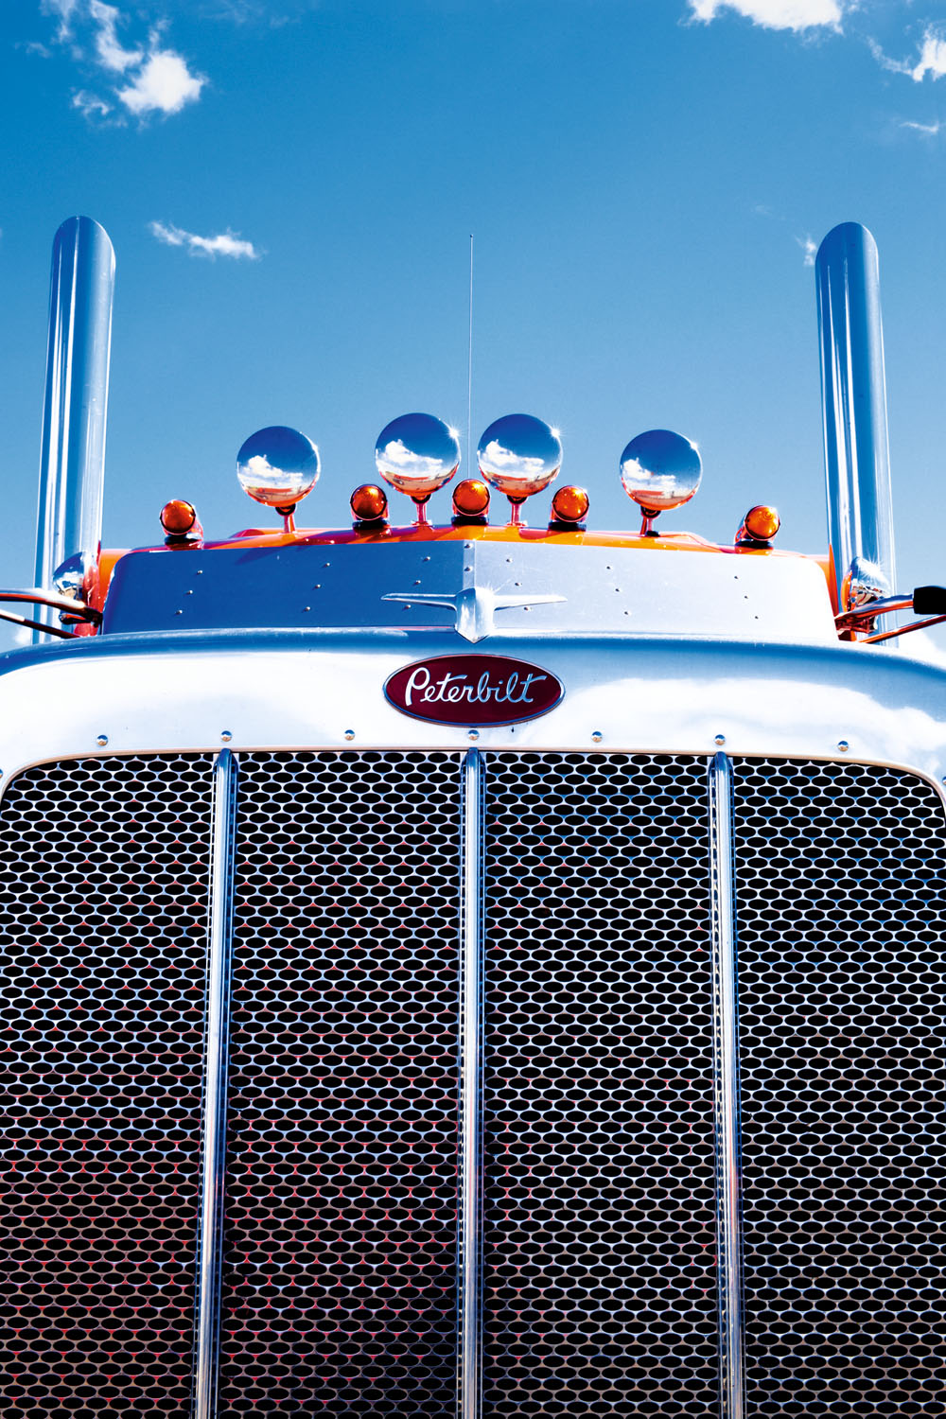  Lupton | 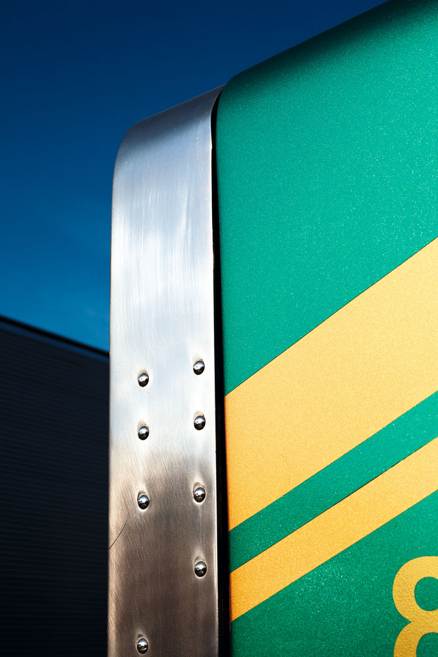  Eight | 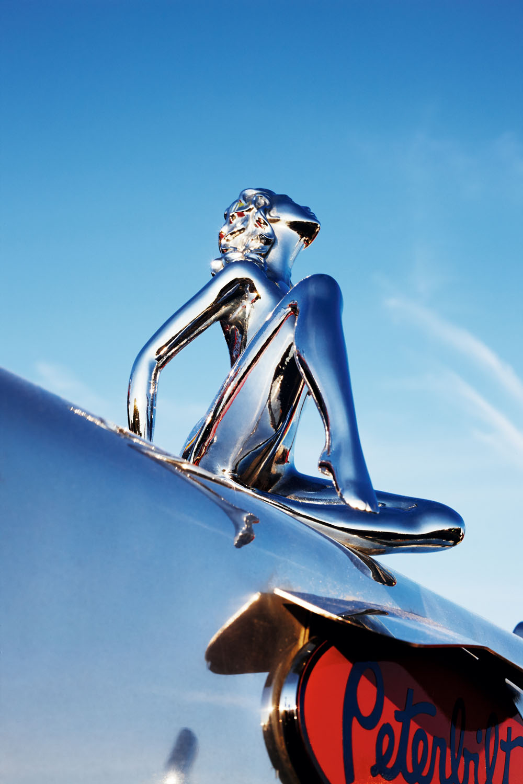  Stainless Steel Woman | 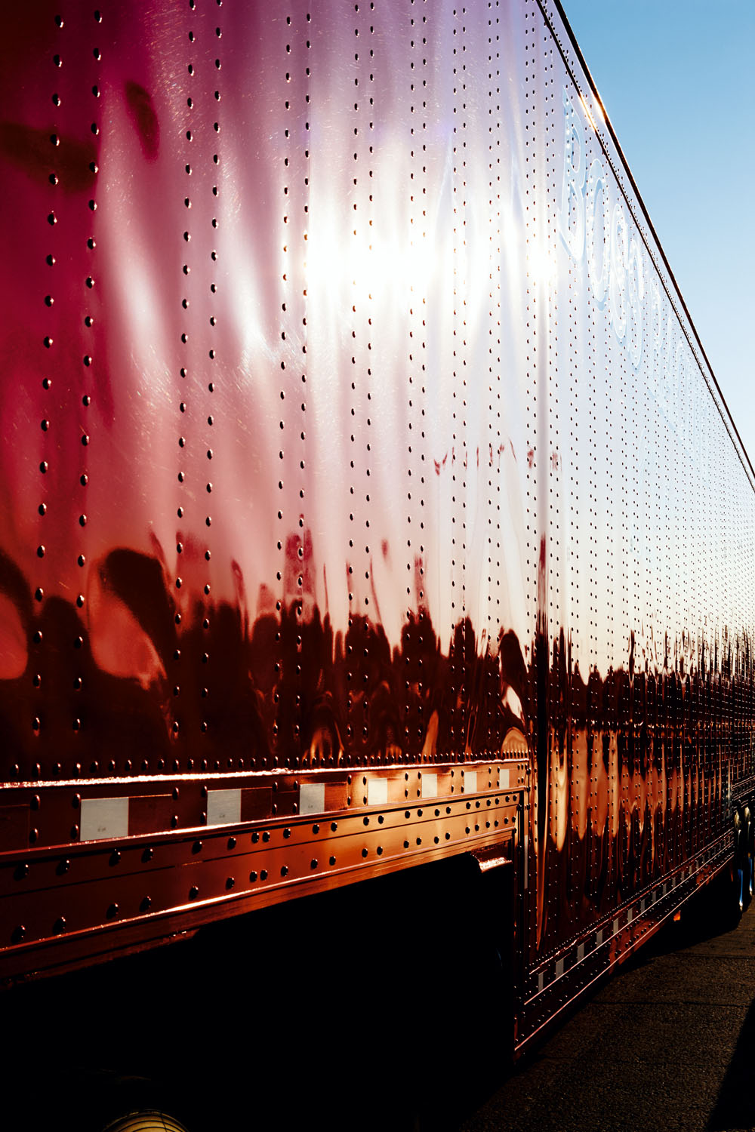  Evening Shine
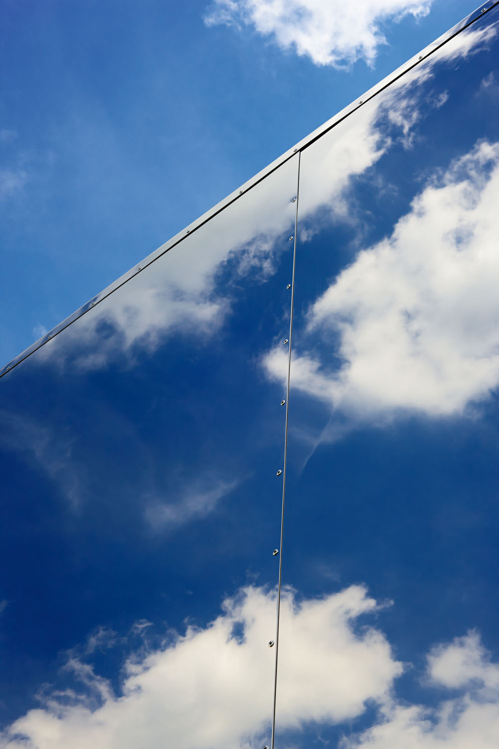  Mirrored Clouds | 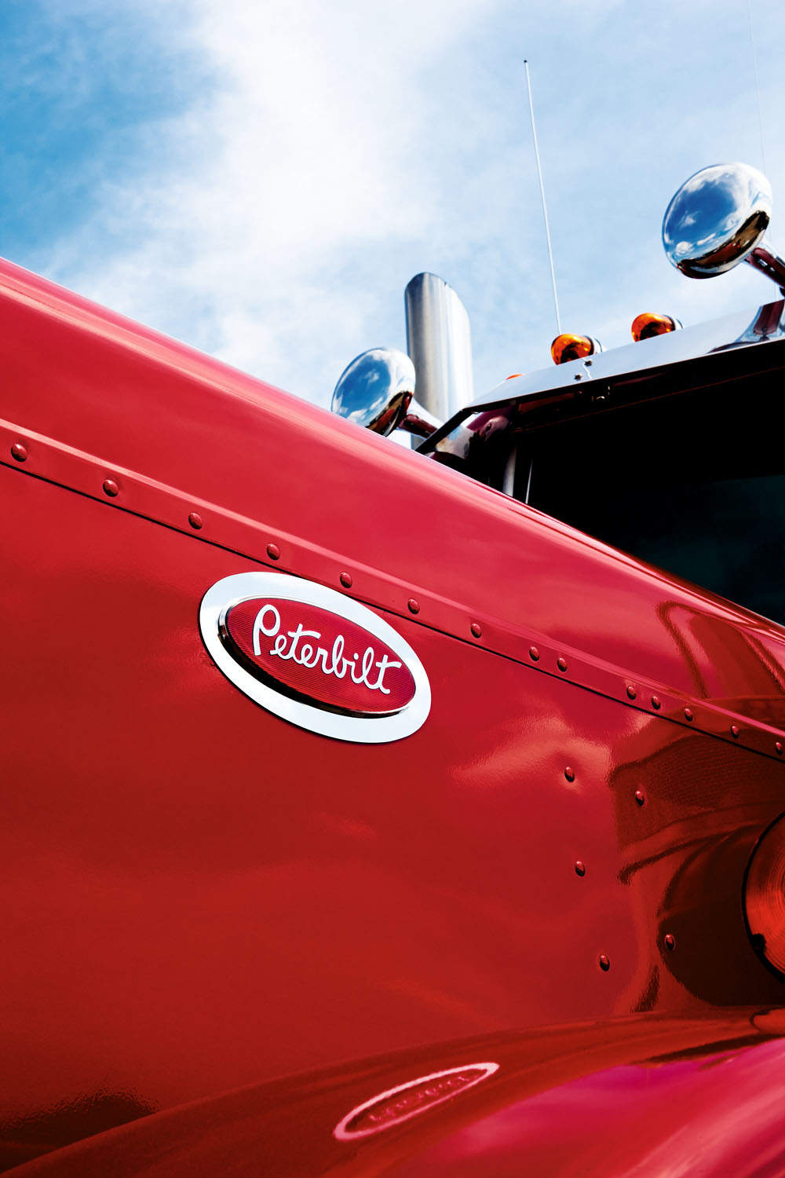  Walcott | 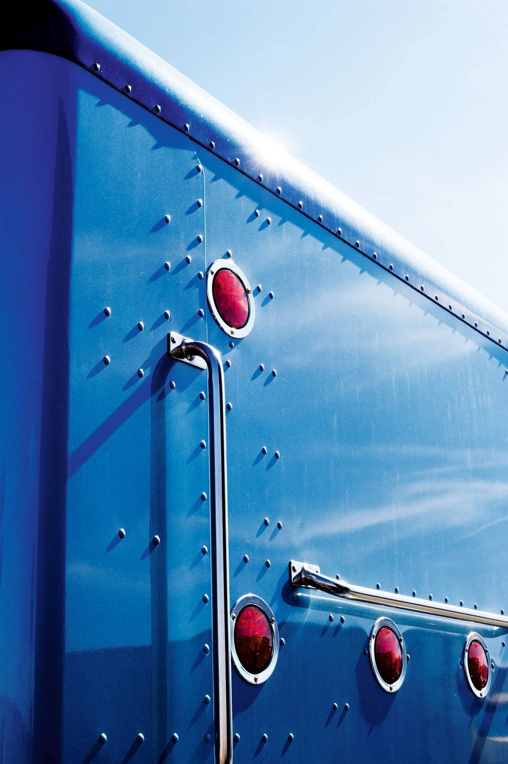  Blue Back | 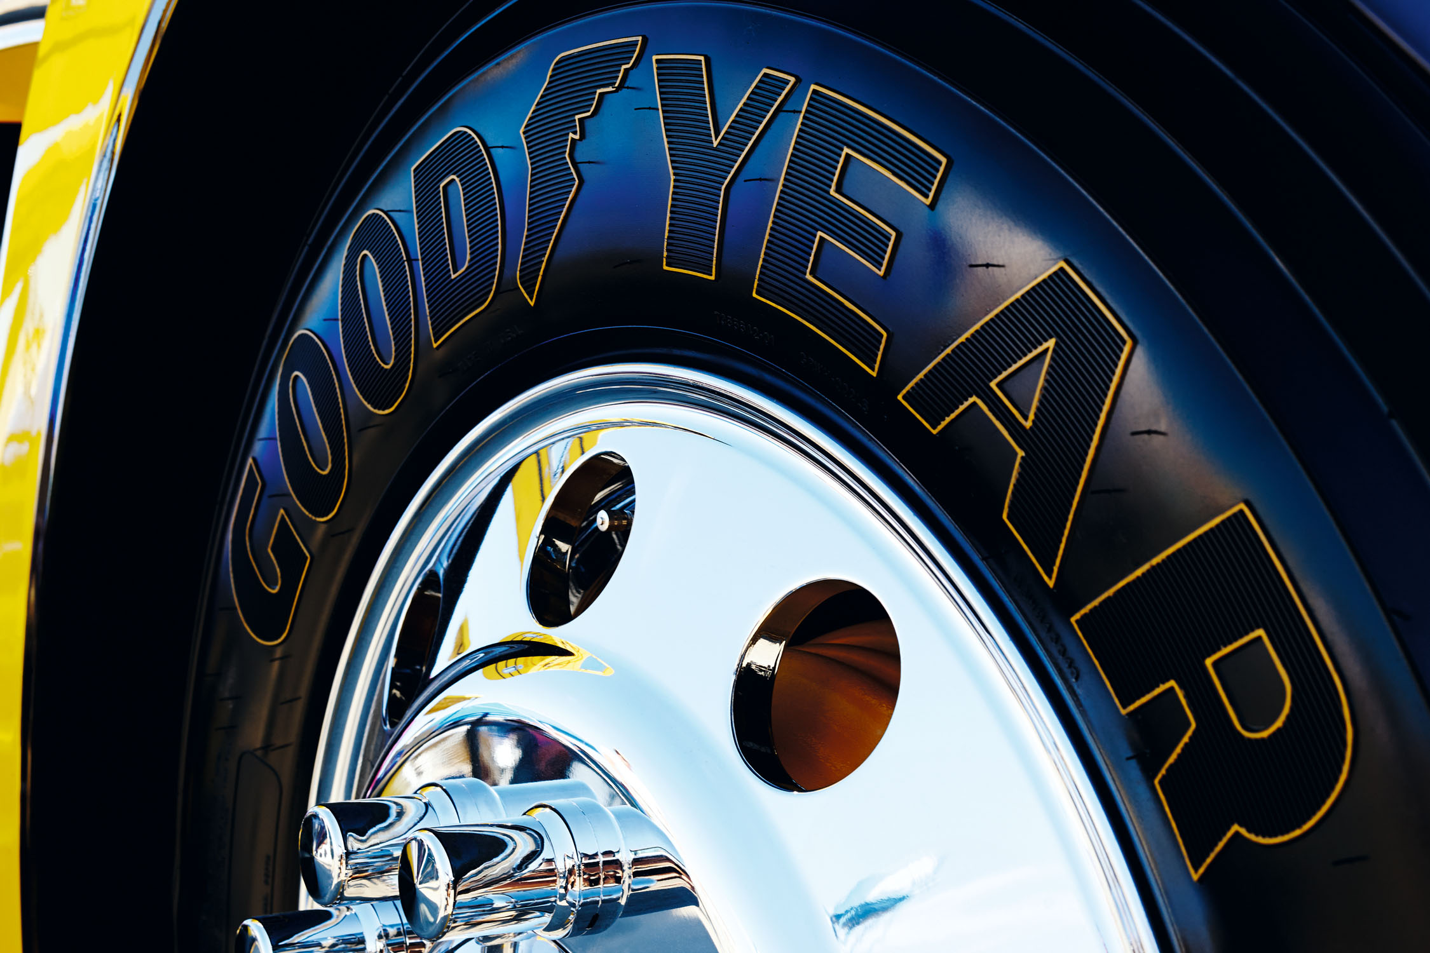  Goodyear

“Lupton”, “Eight”, “Stainless Steel Woman”, “Evening Shine”, “Mirrored Clouds”, “Walcott”, “Blue Back”
90 x 120 cm with frame
Price: CHF 1’900.- including Swiss VAT

“Goodyear”
140 x 100 cm with frame
Price: CHF 2’200.- including Swiss VAT

“American Trucks”: The Book

Standard Edition
Price: CHF 95.- including Swiss VAT

Limited Edition in a slipcase: 100 copies, numbered and signed by the artist
Price: CHF 195.- including Swiss VAT

