MB&F M.A.D.Gallery Dubai presents
Xia Hang’s ‘Sleep Walker’ Series showcasing intricate and monumental steel sculptures from 18th October 2016 – 18th January 2017

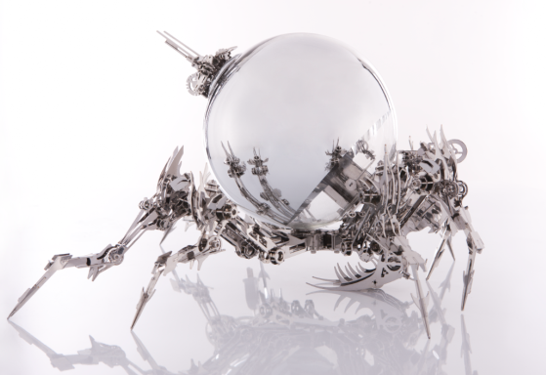
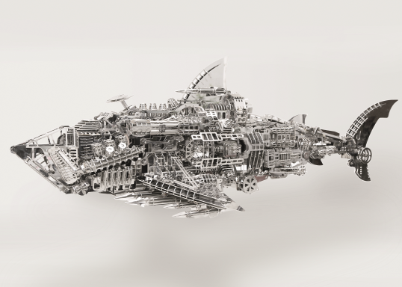

Dubai, UAE – M.A.D.Gallery Dubai, the Middle East’s first mechanical art gallery will be showcasing an exhibition of works by renowned Chinese artist Xia Hang. Entitled “Sleep Walker” the exclusive exhibition will run from 18th October 2016 till 18th January 2017, and will showcase the best from the world of complex metal sculptures.

The “Sleep Walker” exhibition is a commentary on the relationship between simulated 3D technology and reality. The exhibition will offer ten pieces that have been crafted from steel and are monumental in size, spanning up to 2 meters. A master sculptor, Xia Hang has always been fascinated by the medium of steel, attracted by its brilliant shine, strength and durability. Stronger than stone or wood, Xia Hang enjoys the malleability of steel and is able to manipulate the metal into shapes that challenge the traditional conventions of the art of sculpting.

Born in 1978 and a graduate of China’s Central Academy of Fine Arts, Xia Hang is a pioneer in the adoption of the “sculpture of play” as a form of artistic creation; his works are born out of a sense of “play”, with cartoons and on-line games influencing his works and underscoring them with a light mood and free spirit.
Experiencing a creative process that is filled with imagination and challenges, Xia Hang creates sculptures that are a reinterpretation of the concept of "play" with modern material, techniques and concepts. A core element to his art works is also the concept of "Disassembling" and "Re-assembling" where Xia Hang’s sculptures can be disassembled and reassembled, mirroring once again, the concept of "play" with modern materials, like steel.
M.A.D.Gallery Founder and Creator Maximilian Büsser said: “The M.A.D.Gallery is a haven for mechanical pioneers and we are privileged to showcase works by Xia Hang. We are always on the lookout for unique artists who can juxtapose creativity and artistic integrity to create works of mechanical art and in Xia Hang we have met a kindred spirit who is not afraid to challenge the status quo”.

M.A.D.Gallery is located at Alserkal Avenue, Street 8 in Al Quoz 1, Dubai and is open to the public from 10:00 am to 7:00 pm daily, Saturday to Thursday.

– END –

For further information please visit www.madgallery.ae or contact the below:

Mobile: +971 509116138
E-Mail: Zaib@Shadaniconsulting.com

About M.A.D.Gallery:
The MB&F M.A.D.Gallery is a captivating universe of kinetic art where Horological Machines and Mechanical Art Devices reign supreme. The first M.A.D.Gallery opened in 2011 in Geneva on Rue Verdaine, a stone’s throw from MB&F’s offices and atelier in the heart of the city’s old town. A second location opened in 2014 in Taipei and now a third in Alserkal Avenue, Dubai. Inside the galleries, you have the pleasure of discovering carefully-curated pieces – or, as we like to call them, Mechanical Art Devices – from around the world, each one making your heart beat that little bit faster. You exhale, only then to find the complete range of MB&F Horological Machines and Legacy Machines.

About MB&F:
Based around one very simple and fundamental ideal: to assemble dedicated Collectives of talented horological artisans, artists and professionals – all friends – to design and craft each year a radical and original horological masterpiece. By nurturing teams of talented individuals, harnessing their passion and creativity and crediting each individual's essential role, MB&F uses their synergy to become much greater than the sum of its parts. MB&F is above all a human adventure... a human adventure with just one goal: to create incredible horological machines. In 2015 MB&F celebrates its 10th Anniversary: 10 years and 10 calibers!
About Ahmed Seddiqi &Sons:
Ahmed Seddiqi & Sons is the Middle East’s most trusted destination for luxury watches and jewellery, representing more than 60 of the leading timepiece brands across a retail network of 65 locations in the UAE. Established in 1950 through, Ahmed Seddiqi & Sons is recognized among the leading retailers in the region, advising and enabling both established and emerging watch enthusiasts to increase their passion and understanding of the art of watchmaking. From the most complicated, limited edition timepieces created by the world’s most respected watchmakers to the latest collections of high-end jewellery brands, the company aligns with its customers’ needs to offer the region’s most expansive collection for the coveted collector.

Dedicated to a superlative customer service experience, Ahmed Seddiqi & Sons has persistently curated and invested in a highly skilled, culturally aware team for the last six decades. From expert pre-sale insight from its sales consultants to the internationally recognized aftersales offered through the Swiss Watch Services, Ahmed Seddiqi & Sons is the Middle East’s only retailer which offers its clients a full lifecycle for luxury watches and jewellery. The passion and credibility of the second, third and fourth generation of Seddiqi family members managing the organization deliver a living legacy and dynamic commitment to preserve and grow the tradition of watchmaking for decades to come.

The story of Ahmed Seddiqi & Sons contributes to the Middle East’s status as a hub for international trade and economic development. As a pillar of the Gulf’s retail landscape, Ahmed Seddiqi & Sons has significantly enhanced trade opportunities with key markets while developing substantial career development opportunities for both nationals and expatriates. Through its ongoing work with the region’s education and cultural communities, Ahmed Seddiqi & Sons is creating a sustainable platform for watchmaking, servicing, and collecting for the entire Middle East.

M.A.D.Gallery Dubai
Address: H-81, AlSerkal Avenue, Street 8, Al Quoz1, Dubai, U.A.E
Tel.: +971 433 073 66
info@madgallery.ae

M.A.D.Gallery Geneva
Address: Rue Verdaine 11, 1204 Geneva, Switzerland
Tel.: +41 22 508 10 38
info@madgallery.ch

M.A.D.Gallery Taipei
Address: The Arcade Ground Floor Lobby, 166 Dun Hua N. Road, Taipei 105, Taiwan
Tel.: +886 2 2545 0018
madgallery.taipei@swissp.com

Follow M.A.D.Gallery Dubai

www.madgallery.ae
Facebook: MB&F MAD.Gallery Dubai
Instagram: mbfmadgallery.ae
Snap Chat: MBANDF

