MB&F M.A.D.GALLERY LAUNCHES “MECRE” EXHIBITION – FUTURISTIC MECHANICAL ART THAT REPRESENTS THE EVOLUTION OF INSECTS
Riveting mechanical art pieces will be on display from the 12th of December 2018 to 30th of March, 2019 at MB&F M.A.D.Gallery, Dubai Mall
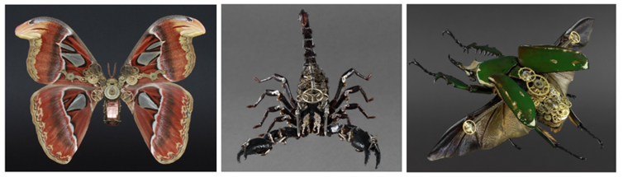

Dubai, UAE – 12 December 2018: The MB&F M.A.D.Gallery is proud to showcase sixteen evolutionary insects from the series “MeCre” (short for “Mechanical Creatures”) by German mechanical artist Gaby Wormann, at her first exhibition in the Middle East. Inspired by the writings of Franz Kafka and the work of artists H.R. Giger and Pierre Matter, Gaby Wormann takes tiny components from the world of watchmaking and mechanical engineering – gears, plates, balance springs and filaments, for example – and incorporates them into the bodies of prepared insects – as beautiful bespoke mechanical exoskeletons. Wormann’s art features astonishing creations that demonstrate a rare mastery and represent her futuristic vision of the evolution of insects: new, hybrid lifeforms which are organisms fused with mechanics that are more resistant, efficient and technically optimized.
After intense research of insect physiques and biomechanics studies, Wormann will be showcasing her biggest creatures yet, resulting in a series of bionic insects that appear eerily real: if the sight of a Giant Spider isn’t arresting enough for you, then Wormann’s Tarantula – Theraphosa Blondi secundus with mechanized body and mechanically enhanced legs, surely takes this arachnid to a whole new level of exoticism. Likewise, her Chalcosoma Atlas Sextus possesses impressive layers of mechanical gears endowing this large-winged giant beetle with even more three-dimensionality than Mother Nature provided, while Wormann’s Scorpion sextus with its super-sized sharp claws and four bionic legs offers an unforgettable glimpse into the world of hybrid insects.
“I discovered Gaby’s work on the internet a few years back and was immediately mesmerized. The incredible mastery of her “Mechanical Grafting” technique is unparalleled worldwide, and the results are breathtaking. Her “Mechanical Creatures” leaves one overwhelmed in fascination and I am thrilled to finally be able to showcase her work in Dubai, after several successful exhibitions in Geneva and Taipei,” said Maximilian Büsser, Founder and Curator of MB&F M.A.D.Gallery.
“Insects inspire me, they are a marvel creation of nature and very fragile beings. To modify their bodies in a technical way and to give them a new futuristic identity is an artistic challenge – a photo, illustration or digital rendering will never adequately transform my vision as people need to experience it in real life to see the beauty and intricacies of these mechanical creatures. I am very proud to get this amazing opportunity to exhibit my best and most elaborate creations at the MB&F M.A.D.Gallery in Dubai,” said Gaby Wormann.
The “MeCre” exhibition will be on display at the MB&F M.A.D.Gallery, Dubai Mall, from 12th of December 2018 to 30th of March 2019 and include:

Theraphosa blondi secundus  Size: 38 x 32 x 10cm  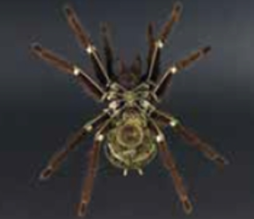 | Dynastes hercules quintus  Size: 38 x 32 x 10cm  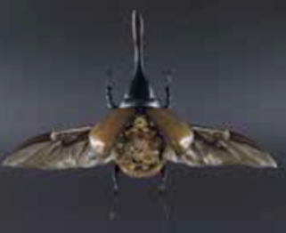
Mecynorrhina septimus  Size: 28 x 24 x 8cm  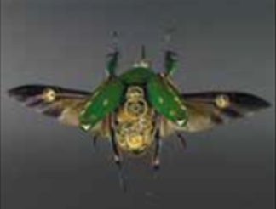 | Chalcosoma atlas sextus  Size: 28 x 24 x 8cm  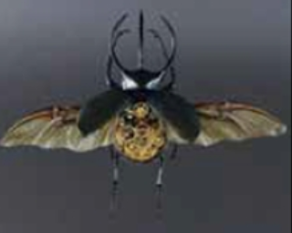
Megasoma actaeon quartus  Size: 38 x 32 x 10cm  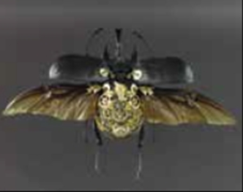 | Callipogon quintus  Size: 38 x 32 x 10cm  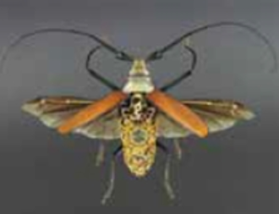
Goliathus ex quintus  Size: 34 x 29 x 8.5cm  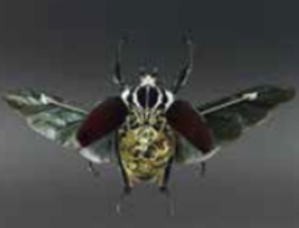 | Attacus atlas secundus  Size: 38 x 32 x 10cm  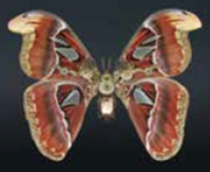

Morpho quintus  Size: 34 x 29 x 8.5cm  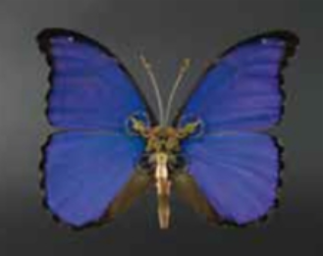 | Lophacris secundus  Size: 34 x 29 x 8.5cm  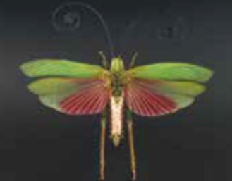
Batocera secundus  Size: 34 x 29 x 8.5cm  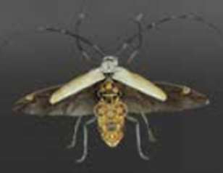 | Macrodontia tertius  Size 34 x 29 x 8.5cm  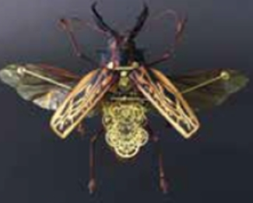
Psalidog  Size: 28 x 24 x 8cm  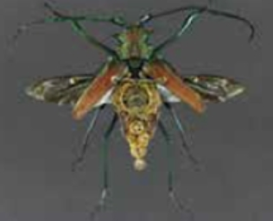 | Scorpion sextus  Size: 34 x 29 x 8.5cm  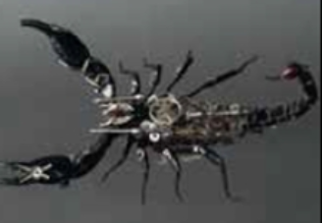
Acanthoscurria  Size: 34 x 29 x 8.5cm  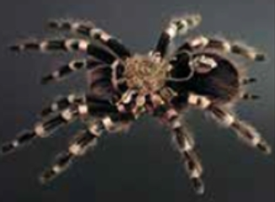 | Heteropteryx  Size: 34 x 29 x 8.5cm  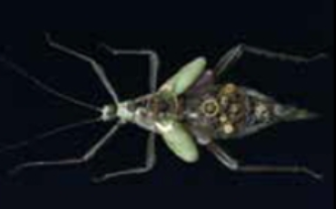

For further information please visit www.madgallery.ae

– END –

About the M.A.D.Gallery:

The MB&F M.A.D.Gallery is a captivating universe of kinetic art where Horological Machines and Mechanical Art Devices reign supreme. The first M.A.D.Gallery opened in 2011 in Geneva on Rue Verdaine, a stone’s throw from MB&F’s offices and atelier in the heart of the city’s old town. Then came Taipei in 2014, Dubai in 2016 and Hong Kong in 2018. Inside the galleries, not only will you find the complete range of MB&F Horological Machines and Legacy Machines, but you’ll also have the pleasure of discovering carefully-curated pieces – or, as we like to call them, Mechanical Art Devices – from around the world, each one making your heart beat that little bit faster.

About MB&F:

Based around one very simple and fundamental ideal: to assemble dedicated collectives of talented horological artisans, artists and professionals – all friends – to design and craft each year a radical and original horological masterpiece. By nurturing teams of talented individuals, harnessing their passion and creativity and crediting each individual's essential role, MB&F uses their synergy to become much greater than the sum of its parts. MB&F is above all a human adventure... a human adventure with just one goal: to create incredible horological machines. 13 years of hyper-creativity; 15 remarkable calibres forming the base of the critically acclaimed Horological Machines and Legacy Machines for which MB&F has become renowned.

About Ahmed Seddiqi & Sons:

Curators of time since 1950, Ahmed Seddiqi & Sons is the Middle East’s most trusted destination for luxury watches and jewellery. Recognised today as a pioneer among the leading retailers in the region, the family owned-and-run company represents more than 60 luxury timepiece brands across 65 locations in the UAE.

An advocate of horology in the region’s retail landscape, Ahmed Seddiqi & Sons continues to create sustainable platforms for watchmaking and servicing, supporting watch enthusiasts and collectors in the region to increase their passion and understanding of the art of timekeeping.

Ahmed Seddiqi & Sons prides itself in offering unparalleled customer service across pre and post-sale dimensions. Led by the passion and credibility of the second, third and fourth generations of Seddiqi family members, the organisation delivers a dynamic commitment to preserving and enhancing the preservation, creation and innovation of watchmaking for decades to come.

www.seddiqi.com

M.A.D.Gallery Dubai
Address: Fashion Avenue Extension, The Dubai Mall, Dubai, U.A.E
Tel.: +971 4 388 2554
info@madgallery.ae

M.A.D.Gallery Geneva
Address: Rue Verdaine 11, 1204 Geneva, Switzerland
Tel.: +41 22 508 10 38
info@madgallery.ch

M.A.D.Gallery Taiwan
Address: 1F, No.2, Aly 232, Sec 1,
Dunhua S Rd, Da'an Dist,
Taipei 106, Taiwan
Tel.: +886 2 2775 2768
madgallery.taipei@swissp.com.tw

M.A.D.Gallery Hong Kong
Address: Shop OT316, Level 3
Harbour City, Ocean Terminal
Tsim Sha Tsui, Kowloon Hong Kong
Tel.: +852 3188 5093
info@madgallery.hk

Follow M.A.D.Gallery Dubai
www.madgallery.ae
Facebook: MB&F MAD.Gallery Dubai
Instagram: mbfmadgallery.ae

